**Vector Network Analyzer Hands-on Basics**

**___**

TRAINING GUIDE

|  |
| --- |
| **What You Will Need**   * Bird BNA1000 or BNA100 Vector Network Analyzer * (2) T5_RFCAB-NmNm_90102 - 9G high precision 50 Ω, N(M)-SMA(m) cable * (1) SK-CAL-NM-90 – Type N(m) Calibration Kit Standards; Open, Short, and Load included * (1) E485A Auto Calibration Kit, Type SMA(f) * (1) ANT-800 – Center Fed Dipole Antenna, 824-894 MHz * (1) 4240-500-10 – Adapter, N (M) to SMA (F) * (2) [433 MHz Bandpass filter](https://www.amazon.com/Anti-Interference-Interface-Reliability-Frequency-Accessory/dp/B08KYMGQM7/ref=sr_1_1?crid=4R5K70XKF7N7&dib=eyJ2IjoiMSJ9.6yCgISSnKtcBwgIO-btLz9_YGxBovXAyYy16cq5LYMI-bcL74hAo5KGD8cMR1vf6huA1ph8bdIPUwy29qsGgEy44qwIsvCwEbnjj0wOnalVV6votfTWzkynWTHAcm5xXh15YiGpi6umKfRQLnistpUoWKIzcr_7mec33X5-xbAQmWDHFunw_1AFNHa3844i3j47CZfxhcQ8jze54coSOl5LMAZMCmIKpsZFvMC4WqOY.Q059RyfTeiPrb2hmJG0QAFhBeSFmkhvsaZHw7J74aS0&dib_tag=se&keywords=433+MHz+bandpass+filter&qid=1709584470&sprefix=433mhz+bandpass+filter%2Caps%2C85&sr=8-1-spons&sp_csd=d2lkZ2V0TmFtZT1zcF9hdGY&psc=1) * (2) [50-ohm terminator, SMA(m), 1 W, 4 GHz](https://www.digikey.com/en/products/detail/pasternack/PE6150/21357292) * (1) [Directional Coupler, TRM DCS1070, 0.5-4.0 GHz, -10 dB](https://www.quantictrm.com/product-details/dcs1070) |

Introduction

In RF engineering, a common task involves analyzing circuits using a vector network analyzer (VNA)—an instrument designed for precise and efficient measurements. Network analyzers handle a broad range of circuits, from simple devices like filters to complex modules in communication satellites. Considered the most intricate testing equipment in RF engineering, network analyzers are crucial for both research and development and testing in production.

The following sections will present to you some common tasks that the user of VNA will encounter, giving you first-hand experience in the setup and operation of the instrumentation and tools necessary to perform measurements.

1-Port Calibration

While you may want to reason that there is no immediate need for calibration if your VNA came calibrated when you ordered it as a new purchase and it is still well within the 1-year recommended calibration cycle, it is important to make the distinction between a *factory* calibration and a *measurement* calibration. *Factory calibration* is focused on verification of the instrument performance with the possibility of adjusting internally preserved scaling or offset coefficients so that the instrument meets and maintains its published specifications. This process is typically quite involved and may require certification that the instrument meets a certain calibration based on an accredited standard. This is typically performed annually or biannually by a qualified technician at the equipment manufacturer’s facility or a designated service center.

Due to the sensitivity of your VNA as well as the devices or circuits you are evaluating, a *measurement calibration* is almost certainly required. The factory calibration only considers instrument performance to the end point of the instrument ports. This virtual stopping point is referred to as the reference plane. As you start adding cables, connectors, adapters, fixtures, or other, you are extending the reference plane beyond the instrument port, adding losses, reflections, phase shifts, and impedance mismatches that are not accounted for by the factory calibration thus resulting in a degradation in

accuracy. While measurement calibration cannot account for and resolve all sources of uncertainty (for example, temperature drift), it greatly helps to compensate for most system imperfections and provides you with the best possible accuracy.

Just as not all mechanical setups will be the same for different device configurations, the same can be said with respect to their signal operating conditions. Since your device will be tuned to operate in a certain RF band you will want to ensure that your vector network analyzer is corrected using similar conditions to what the device’s application calls for. Any time there are changes to the start or stop frequencies, the intermediate frequency bandwidth (IFBW), or the number of points in a sweep, a measurement calibration should be performed.

The following steps are provided to get you familiar with the 1-port calibration procedure and use of the VNA software to perform it.

FOR THIS EXERCISE YOU WILL NEED

* BNA100 or BNA1000 Vector Network Analyzer (VNA)
* (1) Calibration kit, type N(m) connectors (SK-CAL-NM-90)
* (1) Adapter, N(m)-to-SMA (f) adapter (4240-500-10)
* (Optional) Stopwatch

PROCEDURE

1. If you have not done so already, obtain and install a copy of the Bird TVNA software used to interface with the VNA. The latest software can be obtained here.
2. Connect power to the VNA and ensure the rocker switch on the rear of the instrument is set to the ON position.
3. Connect a USB cable between your PC and the VNA.
4. Press the power standby button on the front of the VNA to power the instrument ON. You will see the status LED above the button glow green and then will hear the fans start up.
5. Launch the Bird TVNA software on your PC.



1. Using the menu bar in the software, navigate to ***Stimulus->Start***, then enter “**1M**” as your sweep starting frequency. You can confirm the setting in the lower left corner of the user interface (UI).

1. Navigate to ***Stimulus->Stop***, then enter “**2.4G**” as your sweep stopping frequency. You can confirm the setting in the lower right corner of the UI.

1. Navigate to ***Stimulus->Points***, then enter “**401**” as your number of sweep points. You can confirm this setting at the bottom left of center in the UI.



1. At the top of the function button column, click the **purple button** once to return to the main Calibration options.
2. Disconnect any/all cables and adapters from Port 1 of the VNA.
3. Describe what you see in the display area, providing an approximate average of the gain value in dB.

____________________________________________________________________________________________________________________________________________________________________________________________________________________________

1. Record the time you started the calibration. ________________________________________________________________________________________
2. Connect the **Open** device of the SK-CAL-MN-90 calibration standard directly to Port 1, making it finger-tight.

1. Using the right-hand side function buttons, navigate to ***Calibration->Cal Kit***, and navigate through the list of options until you find the **SK-CAL-NM-90** option then click on it to select.
2. At the top of the function button column, click the **purple button** once to return to the main Calibration options.
3. Click on the **Calibrate** function button, then click the **1-Port Cal** function button.
4. Click on the dark gray **Select Port** function button, then select the **1(S11)** option.

You will notice that when this returns you to the previous function buttons view the port value will be the same. This is expected – this particular step is to familiarize you with the location of the option setting.

1. Click on the **Open** function button then choose the **Open 1 [Open -M-]** option. This will perform the measurement on the open with the male gender standard in place. Once complete, a dark dot will be placed next to the button text.

1. Click the purple **Open** button to return up one level.
2. Disconnect the Open device connection at Port 1 then connect the **Short** device of the SK-CAL-SMAF-90 calibration standard, making it finger-tight.

1. Click on the **Short** function button then choose the **Short 1 [Short -M-]** option. This will perform the measurement on the short with the male gender standard in place. Once complete, a dark dot will be placed next to the button text.

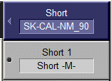

1. Click the purple **Short** button to return up one level.
2. Disconnect the Short device connection at Port 1 then connect the **Load** device of the SK-CAL-SMAF-90 calibration standard, making it finger-tight.

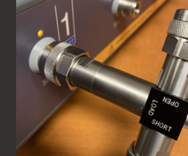

1. Click on the **Load** function button to perform the measurement on the load with the male gender standard in place. Once complete, a dark dot will be placed next to the button text.



1. Click the **Done** button to save the correction measurements. This will clear all the dark dots from the Open, Short, and Load buttons.
2. Record the time you completed the calibration then use the time captured in step 12 to compute the approximate duration of cal. ________________________________________________________________________________________
3. Click the purple button at the top of the function buttons column **twice** to return to the main Calibration options. You will notice that the lower text on the Correction button now reads “ON”.

1. On the menu bar, navigate to ***Response->Scale*** then click on the **AutoScale** button to perform auto scaling of the sweep response trace.
2. Describe what you see in the display area, providing an approximate average of the gain value in dB.

____________________________________________________________________________________________________________________________________________________________________________________________________________________________

Antenna Characterization

An antenna is tuned so that its length best matches the radio frequency wavelength on which it intended to operate. Using an untuned or unmatched antenna will result in poor transmission and reception thereby reducing its range as well as loss of data and increased device power consumption. The impedance imbalance can dramatically increase reflected power and, in some cases, may result in damage to the transmitter.

The following exercise will walk you through the setup for antenna analysis and introduce you to an additional VNA calibration consideration and some additional awareness of channel/trace views.

FOR THIS EXERCISE YOU WILL NEED

* BNA100 or BNA1000 Vector Network Analyzer (VNA)
* (1) Calibration kit, type N(m) connectors (SK-CAL-NM-90)
* (1) Adapter, N(m)-to-SMA (f) (4240-500-10)
* (1) Bird ANT-800 antenna

PROCEDURE

1. Disconnect any/all cables, adapters, or devices from Port 1 of the VNA.
2. Using the menu bar in the software, navigate to ***System->Preset***, then click on the “**OK**” button to restore your VNA to factory default settings.
3. Connect the type N-to-SMA adapter to the ANT-800 antenna then connect this assembly (with the antenna pointing upright) to Port 1 of the VNA.

1. On the VNA software display, you should be able to identify four main areas where the return loss has the greatest magnitude:

1. Using the menu bar in the software, navigate to ***Markers->Add Marker***, then use your mouse to drag the maker to the lowest point in each of the four regions, recording the frequency value in the lines below. Additionally, perform an internet search to determine the band that each frequency fall into:
   1. _______________________________
   2. _______________________________
   3. _______________________________
   4. _______________________________
2. Because the ANT-800 is intended for use with signals between 824 and 894 MHz, you will focus on the first large dip of the four. Since we know the approximate range to work within, we will now want to calibrate the VNA to optimize for best possible measurements. **Disconnect the antenna and adapter** from Port 1.
3. Using knowledge from the previous section, **perform a 1-Port calibration** using the following settings:
   1. Start frequency: **800 MHz**
   2. Stop frequency: **950 MHz**
   3. Points: **1001**
4. After the calibration is complete, leave the **Load** of the calibration standard connected to the port.
5. Increase the number of trace view by using the menu bar to navigate to ***Display->Num of Traces*** and select **3**.
6. Then change the layout of the traces, first navigating to ***Display->Allocate Traces*** and choosing the x3 option that has one long horizontal trace along the top and two side-by-side traces along the bottom.

1. Single-click on the blue **Tr2** text to highlight it.



1. Use the menu bar to navigate to ***Response->Measurement*** the choose the **S11** option from the function buttons on the right-hand side of the UI.
2. Navigate to ***Response->Format*** and click on the **SWR** function button.

1. Single-click on the magenta **Tr3** text to highlight it.



1. Use the menu bar to navigate to ***Response->Measurement*** the choose the **S11** option from the function buttons on the right-hand side of the UI.
2. Navigate to ***Response->Format*** and click on the **Smith** function button followed by the **R + jX** button.



1. Double-click the magenta **Tr3** text to maximize the trace view.
2. Record the value reported by the Marker 1 reading:

__________________________________________

1. Does this reading make sense? Explain:

________________________________________________________________________________________________________________________________________________________________________________

1. Double-click the magenta **Tr3** text to minimize the trace view.
2. Disconnect the **Load** from Port 1.
3. Disconnect the adapter from the antenna and take a minute to visually evaluate the adapter.

* 1. Does the input to output of the connector have zero length? ___________________
  2. Does this mean that the measurement reference plane for the VNA will move? _________________________________

1. If the speed of electricity through copper wire is approximated at 5.1 ns/m, and the change in measurement reference plane length is 7.8 mm, what is the approximate electrical delay in nano-seconds (ns)? ____________________________________
2. We can account for this minor change in measurement reference plane by applying a port extension, directing the VNA to account for the difference in its measurement calibration coefficients. To apply port extensions, click on the **purple** function button until you reach the **Main Menu**, then click on **Calibration** followed by **Port Extensions**.
3. Click the **Extensions** button to toggle the feature ON.

1. Click on the **Extensions Port 1** button then use the numeric entry bar to input your electrical delay value.

1. Your adapter may be different than the 4240-500-10 used in the last few steps. If you do not have a datasheet to help determine the length to account for, the VNA provides a way to perform the measurement for you. **Connect the adapter** to Port 1.
2. Click on **Auto Port Extension** button.

1. Click on **Select Port** and ensure only port **1** is accounted for.

1. Click the **Measure Open** button, then click on the **purple** function button to navigate up one level. Record the value being reported in the text field just below the button reading “Extension Port 1”.

_______________________________________

How does this compare with the value you computed earlier and why might this be the case? ____________________________________________________________________________________________________________________________________________________________________________________________________________________________

1. Connect the antenna to the adapter and ensure the antenna is pointing upright.
2. Double-click the yellow **Tr1** text to maximize the trace view so that return loss can be examined.



1. Use the menu bar to navigate to **Response->Scale** then click on the **Auto Scale** function button.
2. **Add two more markers** to the screen and move Marker 2 to the first -10 dB return loss point and Marker 3 to the next, then locate Marker 1 to the maximum loss (lowest) point. Record the frequencies for each.

**Marker 1: ________________________**

**Marker 2: ________________________**

**Marker 3: ________________________**

With the ANT-800 specified to work between 824 and 894 MHz, explain how your readings compare with expectations: ________________________________________________________________________________________________________________________________________________________________________________

1. Double-click the yellow **Tr1** text to minimize the trace view.
2. Double-click the blue **Tr2** text to maximize the trace view so that reflection can be examined.



1. Use the menu bar to navigate to **Response->Scale** then click on the **Auto Scale** function button.
2. The SWR values for the working band of your antenna should be less than 2 to ensure best performance. Record the SWR values for each marker.

**Marker 1: ________________________**

**Marker 2: ________________________**

**Marker 3: ________________________**

1. Because the antenna is designed to work with 50-ohm devices, you can check its match capability using the Smith chart. Double-click the blue **Tr2** text to minimize the trace view.
2. Double-click the magenta **Tr3** text to maximize the trace view so that reflection can be examined.



1. Recall that Marker 1 is the point where the antenna shows the lowest return loss, so seeing it at or near the 50-ohm point gives us the assurance we need to confidently use the antenna for its intended purpose. Record the impedance values for each marker, also indicating whether they have an inductive or capacitive quality to them.

**Marker 1: ________________________**

**Marker 2: ________________________**

**Marker 3: ________________________**

Were any of the measurements of concern to you, and, if so, how might you reason why the value or values are fine or problematic? ____________________________________________________________________________________________________________________________________________________________________________________________________________________________

2-Port Calibration

2-port calibration stands out as the most widely employed and comprehensive calibration technique involving two ports, proving necessary when testing devices such as amplifiers, filters, or attenuators. This method ensures the thorough correction of all four S-parameters—namely, S11, S12, S21, and S22.

A 2-port calibration can be accomplished similar to the 1-port described earlier, though this time capturing correction measurements on both ports using the open, short, and load standards while also including the through standard to couple the ports and account for the S21 and S12 parameters

While you could use the same cal standard as before and basically double the number of connections, this exercise will introduce you to the electronic calibration module and highlight the reason it might be deemed the preferred method by an end customer.

FOR THIS EXERCISE YOU WILL NEED

* BNA100 or BNA1000 Vector Network Analyzer (VNA)
* (2) T5_RFCAB-NmNm_90102 - 9G high precision 50 Ω, N(M)-SMA(m) cable
* (1) E485A electronic calibration module with USB cable

PROCEDURE

1. Disconnect any/all cables, adapters, or devices from the VNA.
2. Using the menu bar in the software, navigate to ***System->Preset***, then click on the “**OK**” button to restore your VNA to factory default settings.
3. Connect the cables to Ports 1 and 2 of the VNA.
4. Connect the E-Cal module to your PC using the additional USB cable.
5. This calibration process will set you up for the exercise in the next session:
   1. Navigate to ***Stimulus->Center*** and enter: **433 MHz**
   2. Navigate to ***Stimulus->Span*** and enter: **20 MHz**
   3. Navigate to ***Stimulus->Points*** and enter: **1001**
6. Record the time you started the calibration and the color of the Status light on the top of the E-Cal module. ________________________________________________________________________________________
7. Connect the free end of the SMA cable leading from Port 1 to input A on the E-Cal module.
8. Connect the free end of the SMA cable leading from Port 2 to input B on the E-Cal module.
9. Click the purple button at the top of the function buttons column until it reads “Main Menu”, then navigate to ***Calibration->ECal->2-Port Cal*** then click on the **Port 1-2** function button.
10. Note any behaviors you witness on the screen. ____________________________________________________________________________________________________________________________________
11. Check to see if the color of the Status light on the top of the E-Cal module has changed. Record the color then record the time use the time captured in step 6 to compute the approximate duration of cal. ________________________________________________________________________________________
12. List any benefits or drawbacks you can think of in using the E-Cal module as opposed to the traditional calibration standard. ____________________________________________________________________________________________________________________________________________________________________________________________________________________________
13. Leave the cables connected to the VNA but disconnect them from the E-Cal module.

Evaluating A Bandpass Filter

VNAs are used to evaluate filter designs, both those that are tailor-made by an engineer to target a specific application as well as general off-the-shelf models manufactured in mass to address applications with common frequency-selective demands. This exercise will leverage the latter, using a bandpass filter found on a popular online shopping website with the intent for it to be used in a wide array of low device power (LDP) configurations that operate using the 70 cm band, specifically at or near 433 MHz, with basic specifications as follows:

The Bird BNA100 and BNA1000 Vector Network Analyzers can be used to verify the return loss and insertion loss of the device. Further, a Smith Chart may be used to evaluate the complex impedance of the device and ensure a good match before being added to the final system design.

FOR THIS EXERCISE YOU WILL NEED

* Bird VNA
* (2) T5_RFCAB-NmNm_90102 - 9G high precision 50 Ω, N(M)-SMA(m) cable
* (2) 433 MHz bandpass filters

PROCEDURE

1. Connect the bandpass filter such that the cable at VNA Port 1 is connected to the “RFin” input and the cable at VNA Port 2 is connected to the “RFout” output.

1. The trace you should be looking at is measuring the **Return Loss** (S11) as seen by Port 1. Click on the purple button atop the function buttons until you return to the main menu, then navigate to **Scale->Auto Scale** to achieve the best possible view of the trace. Your display should look similar to the following:

1. Add a marker using the menu bar to navigate to ***Markers->Add Marker*** and set its frequency location to **433 MHz**.
2. Add another marker, setting its location to **428 MHz**.
3. Because we want to know the frequencies at the -10 dB points on either side of the center frequency, we can use the Marker Search function to accurately place them at the points of interest. Use the menu bar to navigate to ***Markers->Marker Search***.
4. Click on the **Target** function button.
5. Click on the **Target Value** function button then enter the value **-10**.

1. Click on the **Search Target** function button. After the operation is executed, a dot will appear to the left of the button text.

1. Using the measurement information shown in the top left of the display, write the frequency at which Marker 2 is relocated upon finding the -10 dB point. ________________________________________________________________________________________
2. Repeat steps 4 through 9, adding a third marker starting at **438 MHz**, then searching to its nearest -10 dB point.
3. Write the frequency at which Marker 3 is relocated upon finding the -10 dB point.

________________________________________________________________________________________

1. You will notice that not all frequencies between your Markers 2 and 3 are below the ideal -10 dB threshold. **Add another marker** to the trace and use your mouse drag it to the peak of the band that goes above -10 dB. Use the area below to document the frequency and loss magnitude of Marker 4. Also, determine the approximate width of the band that is pushing above this -10 dB. ________________________________________________________________________________________________________________________________________________________________________________
2. It can be quite helpful to view **Insertion Loss** (S21) in the same channel view as our Return Loss (S11). Use the menu bard to navigate to ***Display->Num of Traces*** then click on the function button reading 2.

1. Click on the blue annunciator reading “Tr2”.



1. Use the menu bar to navigate to ***Response->Measurement*** and use the function buttons to select the **S21** option.

1. Navigate to ***Response->Scale->Auto Scale*** to achieve the best possible view of the new trace. Your display should look similar to the following:

1. Recall from our specifications that we can expect <3 dB of insertion loss within the pass band of our DUT. This means that the filter device should not introduce more than 3 dB of loss when added to the circuit or system. Record the loss as indicated by Marker 1 and note whether or not it meets your expectations: ____________________________________________________________________________________________________________________________________
2. It would be reasonable to expect our S21 Markers 2 and 3 to have -3 dB measurements to coincide with the -10 dB return loss points measured earlier in this procedure. Record the loss magnitude for these points in the area below and provide some insights/thoughts on the frequency band shown in between them:___________________________________________________________________________________________________________________________________________________________________________
3. Another way to better gauge the performance capability of our filter device is to enable the Bandwidth Search function of the VNA, which analyzes the measurements of the given trace and uses the information to display values representative of the selectivity of the filter, yielding more mathematically accurate representations of bandwidth, center frequency, upper and lower cutoff points, insertion loss and quality factor. Navigate to ***Markers->Marker Search***.
4. Click on the **Bandwidth Search** function button.

1. Use the function buttons to ensure the Bandwidth Search is set to **ON**, the Type is set to **Bandpass**, the Search Ref To is set to **Markers**, and the Bandwidth Value is set to **-3 dB**.

1. You will notice the additional measurement information appears on screen just below the marker measurements. Use the space below to record your values for BW, cent, low, high, Q, and loss: ____________________________________________________________________________________________________________________________________________________________________________________________________________________________
2. How do these Bandwidth Search values align with the filter specifications? ____________________________________________________________________________________________________________________________________
3. The VNA can also help us understand some of the complex impedance attributes of our filter using the Smith Chart, showing how the nature of circuit changes in response to the frequency. Start by adding a third trace via ***Display->Num of Traces*** then selecting **3**.

1. Navigate to ***Display->Allocate Traces*** and choose the **x2** side-by-side option.

1. Double-click the magenta Tr3 annunciator to expand the trace display.



1. Navigate to ***Response->Measurement*** and click on the **S11** function button.

1. Navigate to ***Response->Format*** and click on the **Smith** function button.

1. Click on the **R + jX** function button.

Your display should appear similar to the following:

Because the design is intended to operate in a 50-ohm system, a bandpass filter with a good match should have its impedance value near the center of the chart where the impedance is 50 Ω. Measurements above the horizontal center line of the chart are inductive in nature; those below are capacitive. The format of the measurements for the markers is the impedance value (Z), followed by is complex components resistance (R) and reactance (jX).

1. Record your Marker 1 impedance measurement components below:
   1. Z = _______________________
   2. R = _______________________
   3. jX = ______________________
2. Provide your insights on whether or not this filter has a good match and share any other observations or hypotheses you might have with respect to the measurements and placement of the markers: ____________________________________________________________________________________________________________________________________________________________________________________________________________________________
3. The large loop around Marker 4 is interesting and could either be something unique to this singular device or part of the overall design that affects all parts produced in the same way. To understand the situation better, you can compare the data from two devices within the same interface. Save the current trace to memory by navigating to ***Display->”Data->Memory”***.
4. Remove the bandpass filter from the cable connections and replace it with a second.
5. Click on the purple button at the top of the function button stack until you reach the Main Menu then use the buttons to navigate to ***Display->Display*** then click on the **Data & Memory** option. At this point you should see two traces displayed on the screen.
6. Document your observations and provide any thoughts on how the information gained from the Smith Chart might inform changes to the filter design. ________________________________________________________________________________________________________________________________________________________________________________________________________________________________________________________________________
7. Disconnect the filter from the VNA.

Evaluating A Directional Coupler

Radio frequency couplers are found in a wide variety of applications within transmission systems of varying classes. These components may be used as the heart of a transmission line power measurement system, or as a means of extracting a sample of the energy present within the transmission line to perform spectrum, modulation, or other types of analysis.

The insertion loss – or coupling loss – is a measure of how much power is lost from the device input to its output. Because this signifies the net unrecoverable power dissipated within the circuit at any frequency within the specified range, this should be as close to 0 dB as possible.

Coupling power indicates the power reduction you can anticipate with respect to the source power passing through the directional coupler from its input to output. The nominal coupling is specified as the average of the maximum and the minimum coupling within the frequency band.

The measured difference between the source output port and the coupling port gives you the isolation capability of the directional coupler.

This section will address test scenarios for characterizing insertion loss, coupling power, and isolation of a directional coupler as well as introducing a few setup configurations you may be exposed to with different device types and VNA models.

FOR THIS EXERCISE YOU WILL NEED

* Bird VNA
* (2) T5_RFCAB-NmNm_90102 - 9G high precision 50 Ω, N(M)-SMA(m) cable
* (1) E485A electronic calibration module with USB cable
* (2) [50-ohm terminator, SMA(m), 1 W, 4 GHz](https://www.digikey.com/en/products/detail/pasternack/PE6150/21357292)
* (1) [Directional Coupler, TRM DCS1070, 0.5-4.0 GHz, -10 dB](https://www.quantictrm.com/product-details/dcs1070)

PROCEDURE

1. Using the menu bar in the software, navigate to ***System->Preset***, then click on the “**OK**” button to restore your VNA to factory default settings.
2. Using knowledge from the previous section, **perform a 2-Port calibration** using the following settings:
   1. Start frequency: **300 MHz**
   2. Stop frequency: **4.2 GHz**
   3. Points: **801**
3. To verify the insertion loss specification of the coupler (which is 1.5 dB), connect VNA Port 1 to the input of the directional coupler; Port 2 to the output of the directional coupler; then add 50-ohm terminators to each of the coupling ports.

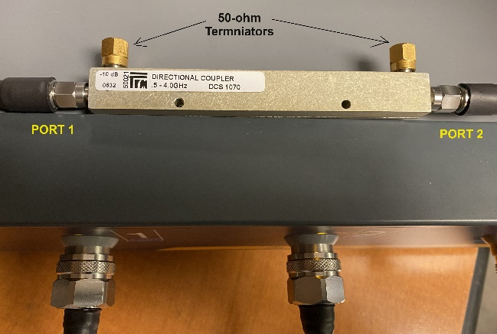

1. Use the menu bar to navigate to ***Response->Measurement*** and use the function buttons to select the **S21** option.

1. Navigate to ***Response->Scale->Auto Scale*** to achieve the best possible view of the new trace. Your display should look similar to the following:

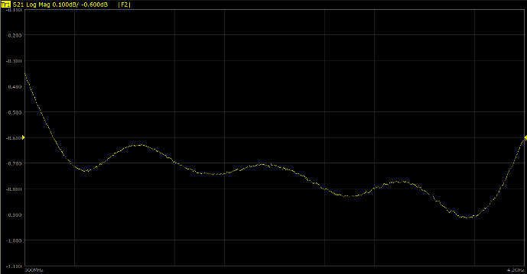

1. Add three markers using the menu bar to navigate to ***Markers->Add Marker*** and set them to the following frequency locations:
   1. 500 MHz
   2. 2 GHz
   3. 4 GHz
2. Write down the loss values for each marker in the spots provided below and verify that each – as well as any of the other frequencies within the band covered by the coupler – does not exceed -1.5 dB:
   1. Marker 1: ___________________
   2. Marker 2: ___________________
   3. Marker 3: ___________________
3. To verify the coupling power, remove the 50-ohm terminator closest to the input end of the coupler then connect the VNA Port 2 to this coupling port. Then place the 50-ohm terminator on the output of the coupler.

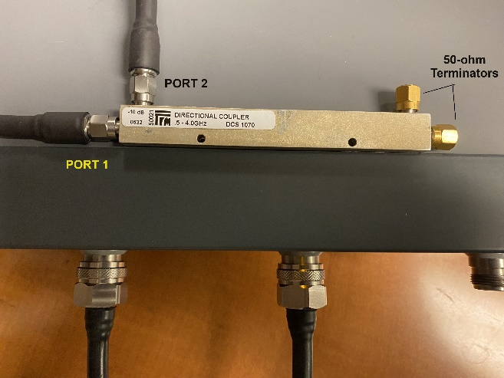

1. Navigate to ***Response->Scale->Auto Scale*** to achieve the best possible view of the new trace. Your display should look similar to the following:

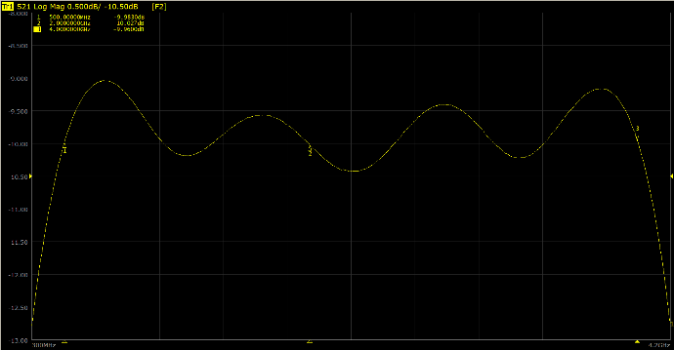

1. The specification for this coupler states that the user can expect -10 +/- 0.5 dB. Write down the loss values for each marker in the spots provided below and verify that each – as well as any of the other frequencies within the band covered by the coupler – does not exceed expectations:
   1. Marker 1: ___________________
   2. Marker 2: ___________________
   3. Marker 3: ___________________
2. While your marker measurements may give you individual passing results, there are likely some spots in the frequency band that appear questionable. Limits functionality can be applied to provide an overall assessment of the coupling response for this device.
3. Use the menu bar to navigate to ***Analysis->Limit Test***.
4. Click on the **Add** function button.
5. In the edit table provided below the trace display, update the first limit line as follows:
   1. Type: MAX
   2. Stimulus Start: 500 MHz
   3. Stimulus Stop: 4 GHz
   4. Response Start: -9.5 dB
   5. Response Stop: -9.5 dB
6. Repeat steps 10 and 11, applying the following settings to the new limit table entry:
   1. Type: MIN
   2. Stimulus Start: 500 MHz
   3. Stimulus Stop: 4 GHz
   4. Response Start: -10.5 dB
   5. Response Stop: -10.5 dB
7. Click the purple button at the top of the function button column once to return up one level, then click the **Limit Test [OFF/ON]** button to enable the test. Your display should look similar to the following, with the failing regions highlighted in red:

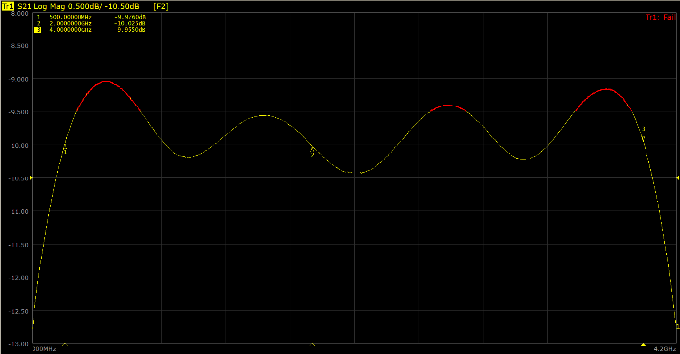

1. To show the boundaries established by the settings in the limit table, click on the **Limit Line [OFF/ON]** button. Your display should look similar to the following:

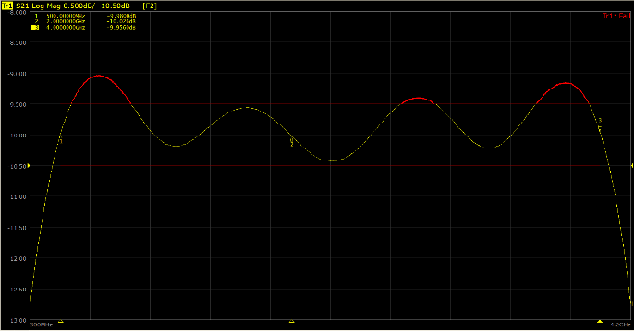

1. For cases where an operator could be distracted, the failure status (shown in the upper right corner) can be made more pronounced in the center of the screen. To do so, click on the Fail Sign [OFF/ON] button. Your display should look similar to the following:

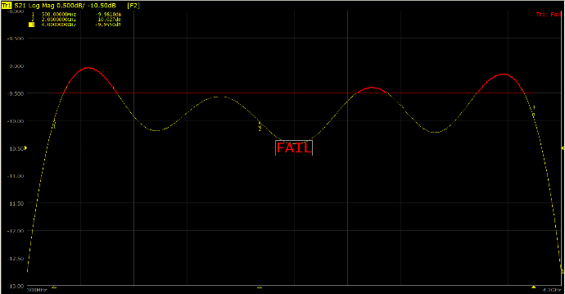

1. If you were to review the [datasheet for this device](https://www.quantictrm.com/product-details/dcs1070), you will not find the isolation specification listed. In this case, isolation can be computed by adding the coupling (-10 dB) with the directivity (-15 dB), resulting in an expectation of about **-25 dB**. Your isolation should be greater than this. To verify the isolation, remove the 50-ohm terminator from the output of the coupler and replace it with the VNA Port 1 connection. Then place the 50-ohm terminator on the input end of the coupler.

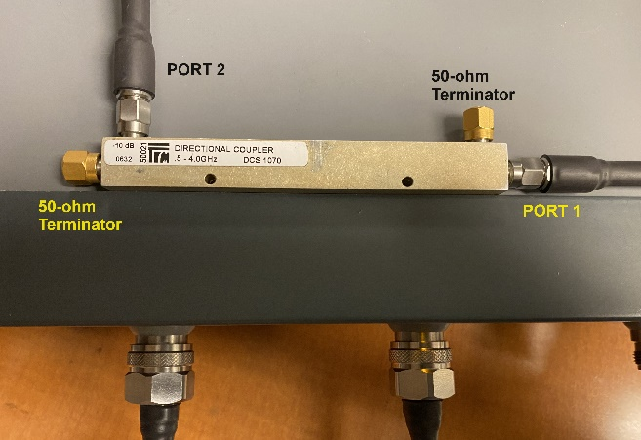

1. Click on the **Fail Sign [OFF/ON]** to disable the fail sign.
2. Click on the **Limit Line [OFF/ON]** to disable the limit lines.
3. Click on the **Limit Test [OFF/ON]** to disable the limit test.
4. Navigate to ***Response->Scale->Auto Scale*** to achieve the best possible view of the new trace. Your display should look similar to the following:

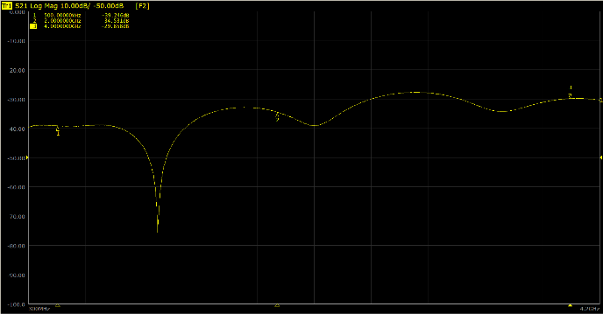

1. Write down the measurements for each marker in the spots provided below and verify that each – as well as any of the other frequencies within the band covered by the coupler – is greater the -25 dB:
   1. Marker 1: ___________________
   2. Marker 2: ___________________
   3. Marker 3: ___________________
2. Disconnect the coupler from the VNA cables.

Answer Key

First

Second

Third

Blah

Blah

Blah

Revision History

|  |  |  |
| --- | --- | --- |
| **Date** | **Editor** | **Notes** |
| 2025-04-22 | J.Brown | Added section for answer key; answers coming. |
| 2024-08-02 | J.Brown | Minor edits based on team feedback. |
| 2024-07-25 | J.Brown | Added section for testing directional coupler. |
| 2024-03-05 | J.Brown | Initial revision. |